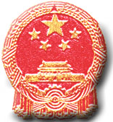

BACHELOR’S DEGREE CERTIFICATE

This is to certify that student xxxx, female, born on November 18, 20xx, has completed four-year undergraduate study programs in xxxxxxx in Harbin University of Science and Technology and graduated. In accordance with the Regulations of the People’s Republic of China on Academic Degree, she/he is hereby conferred the xxxxxx Bachelor Degree.

Harbin University of Science and Technology (seal) President Zhao Lin
President of Academic Degree Assessment Committee
Certificate Serial No.: June xx, xxxx
(Undergraduate of General Higher Education)
Degree Certificate Enquiring Website of The People's Republic of China: http://www.chinadegrees.com.cn

